TICKET RESERVATION

**PROJECT OVERALL DESCRIPTION :**

Bus Booking System is a web based application which is connected to a complete database. The database includes information about buses, no. of seats available, occupancy, availability, days and time of operation, no. of buses  from point ‘A’ to point ‘B’, Price ranges, automated report and bill generation etc .

It manages all customers details ,bus specifications ,withholding details .The databases incorpates all the details about the bus ,no of seat availability ,days and time of operations, number of buses from point A to point B , print limits ,computerised report and invoice generation .

**SCOPE OF THE PROJECT :**

The Online Bus Ticket Reservation System is a web-based application that allows visitors check bus ticket availability, buy bus ticket and pay the bus ticket online. This system is established forall the home/office users after gaining access from the administrator.

This Online Bus Ticket Booking project will provide an Online bus ticket booking platform and thereby leverage the tedious manual ticket booking activity for a customer. We can come up with features like saving favorite routes and providing discounts for the same.

We can provide a feature that will allow the customer to get a ticket booked without much hassle. The bus is one of the most used transportation systems in any country, so in order to make the system more efficient, we are developing a system which will help the user in accessing the service. The Bus Ticket Reservation System is a web-based system which provides functions such as information about the ticket availability, buy a ticket, choose the seat number.

**PROJECT USAGE:**

Customers might use this system to reserve a seat on a bus or book a seat on a plane. This system would also aid the owner in managing the coaches, staff, clients, services, and other aspects of the business. The Bus Reservation System will improve the efficiency, convenience, and comfort of the reservation process.

The main objective of a bus reservation system is to provide better work efficiency, security, accuracy, reliability, feasibility. The error occurred could be reduced to nil and working conditions can be improved. Earlier, people used to avoid bus journey due to poor road infrastructure, lack of luxurious buses, and inefficient bus booking system.

**PROJECT CONSTRAINTS:**

Excel export has not been developed for Trains, Seats due to some criticality.

The transactions are executed in off-line mode, hence on-line data for Booking, Passengars capture and modification is not possible.

Off-line reports of Booking, Stations, Fare cannot be generated due to batch mode execution.

**UML DIAGRAM:**

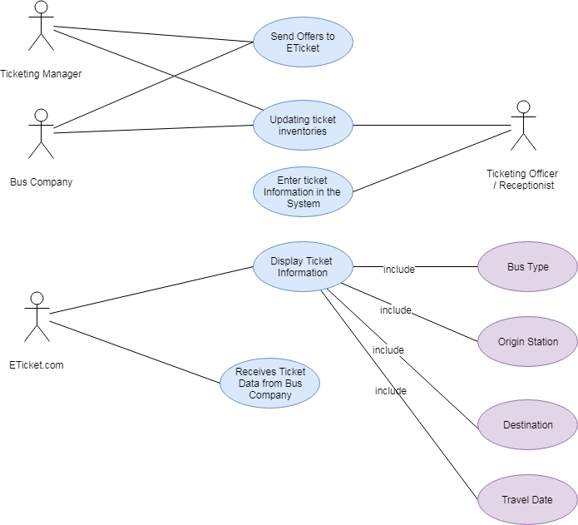

**FUNCTIONAL REQUIMENT:**

• Every online booking needs to be associated with an account

• One account cannot be associated with multiple users

• Search results should enable users to find the most recent and relevant booking options

• System should enable users to book / pay for their tickets only in a timeboxed manner after tickets being added to the cart

• System should only allow users to move to payment only when mandatory fields such as date, time, location has been mentioned

• System should consider time zone synchronisation when accepting bookings from different time zones

**NON FUNCTIONAL:**

• Use of captcha and encryption to avoid bots from booking tickets

• Search results should populate within acceptable time limits

• User should be helped appropriately to fill in the mandatory fields, incase of invalid input

• System should accept payments via different payment methods, like PayPal, wallets, cards, vouchers, etc

• System should visually confirm as well as send booking confirmation to the user's contact

**SOFTWARE REQUIREMENT**:

The client machines require Microsoft Windows XP or better. The corporate server requires Red Hat Enterprise Linux AS 5 (RHEL 5) and Oracle Database11g Enterprise Edition to hold on to all archives. Also, both the client and server computer must have internet browser to work.

**HARDWARE REQUIREMENT:**

We   would   need   the   Intel   Core2Duo   system   and   1   GB   of   Memory   at   the minimum   for   the   client.   The   corporate   server   needs   to   be   a   server   class machine with at least 2 GB and Intel Xeon system per rack and 15 TB of storage at the minimum. And also have the dedicated links between the server and clients.